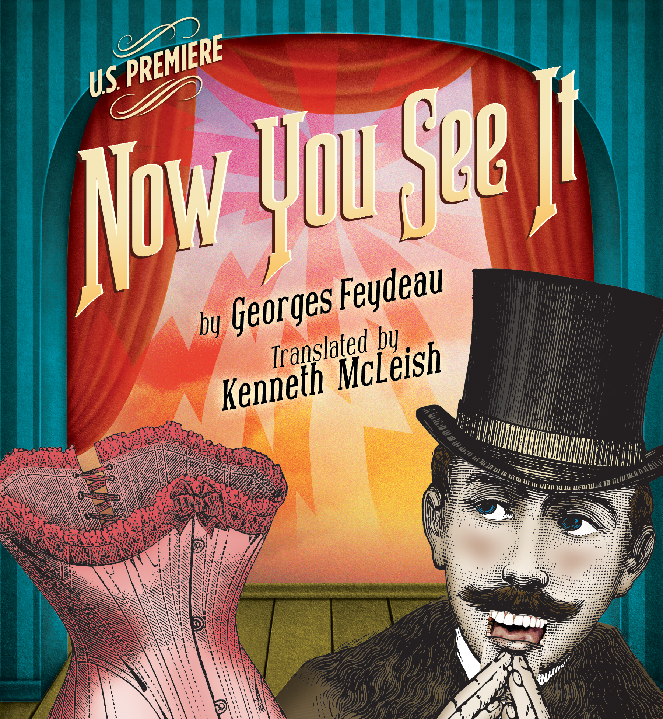
PRESS CONTACT: Nancy Richards – 917-873-6389 (cell)/nancy@northcoastrep.org
MEDIA PAGE: www.northcoastrep.org/press PHOTOS BY: Aaron Rumley

FOR IMMEDIATE RELEASE, PLEASE:

THUNDEROUS LAUGHTER TO ERUPT WHEN CLASSIC FRENCH FARCE,
NOW YOU SEE IT, MAKES ITS U.S. PREMIERE
AT NORTH COAST REPERTORY THEATRE
Performances Beginning Wednesday, February 24, 2016
Opening Saturday, February 27, 2016, at 8 pm
Running Through Sunday, March 20

Solana Beach, CA,
Hasty entrances and exits, jealousy bordering on paranoia, a philandering husband, hypnotism, a spurned lover and a scandalous discovery. Here is classic French farce as only North Coast Rep can do it! NOW YOU SEE IT, written by the French master of the form, Georges Feydeau, in a brilliant translation by British playwright Kenneth McLeish, takes audiences on a dizzying escapade. Furiously fast and clever, this visual and verbal treat is guaranteed to tickle your funny bone. You won’t want to miss this hilarious U.S. premiere.

Bruce Turk directs John Greenleaf*, David McBean*, Kern McFadden*, Allison Minick*, and Ruff Yeager. The staff includes Marty Burnett (Scenic Design), Matt Novotny (Lighting Design), Anastasia Pautova (Costume Design), Melanie Chen (Sound Design), Peter Herman (Hair & Wig Design), Andrea Gutierrez (Prop Design), Jessica Amador (Scenic Artisan), and Kelly Hardy *is the Stage Manager.

NOW YOU SEE IT previews begin Wednesday, February 24. Opening Night on Saturday, February 27, at 8pm includes a post-show reception. There will be a special talkback on Friday, March 4, with the cast and artistic director. It will play Wednesdays at 7pm, Thursdays through Saturdays at 8pm, Saturday and Sunday matinees at 2pm with Sundays at 7pm, through March 20. 2016. (See Schedule below.) North Coast Repertory Theatre is located at 987 Lomas Santa Fe Drive, Solana Beach, CA 92075. Tickets: Previews- $39; Week Nights $46; Sat. Eve. & Sun. Mat $50; Sat. Mat.& Sun. Night $43. Seniors, Students, Military $3 off admission. Call 858-481-1055 or visit www.northcoastrep.org to purchase tickets.

*The actor or stage manager appears through the courtesy of Actors’ Equity Association, the union of professional actors and stage managers in the United States.
For background information and photos, go to www.northcoastrep.org/press.

Please follow North Coast Repertory Theatre on social media as well on Facebook at https://www.facebook.com/North-Coast-Rep
Twitter: https://twitter.com/NorthCoastRep
YouTube: http://www.youtube.com/user/Northcoastrepvideos

Busy director Bruce Turk and his talented cast are available for interviews by phone, in person, and in-studio. For more information and to arrange interviews or press tickets, please contact Nancy Richards at nancy@northcoastrep.org, or 917-873-6389 cell.

FACT SHEET

WHAT: NORTH COAST REPERTORY THEATRE presents the U.S. premiere
NOW YOU SEE IT
by GeorgeS Feydeau
translated by Kenneth McLeish
Directed by Bruce Turk

CAST: John Greenleaf*, David McBean*, Ken McFadden*, Allison Minnick*, Ruff Yeager

WHERE: North Coast Repertory Theatre
987 Lomas Santa Fe Drive
Solana Beach, CA 92075

SCHEDULE*:Previews: February 24-26 at 8pm
Opens: February 27 at 8 pm
Closes: March 20, 2016
Wed. @ 7pm, Thurs-Sat @ 8PM; Sat & Sun @ 2PM, Sun @7pm
Talkback with cast & director: Friday, March 4, 2016

PRICES: Previews $39.00
Week Nights $46.00
Sat. Matinees & Sunday Nights $43.00
Sat. Nights & Sunday Matinees $50.00

DISCOUNTS: Seniors, Students, Military $3.00 off admission

BOX OFFICE (858) 481-1055 or www.northcoastrep.org

FEBRUARY

SUN | MON | TUE | WED | THU | FRI | SAT
 |  |  | 24  Preview  8pm | 25  Preview  8pm | 26  Preview  8pm | 27  OPENING  8pm
28  2pm & 7pm | 29 | MARCH  1 | 2  7pm | 3  8pm | 4  8pm  Talkback | 5  2pm & 8pm
6  2pm & 7pm | 7 | 8 | 9  7pm | 10  8pm | 11  8pm | 12  2pm & 8pm
13  2pm & 7pm | 14 | 15 | 16  7pm | 17  8pm | 18  8pm | 19  2pm & 8pm
20
2pm & 7pm

BACKGROUND:
Season 34 continues with the West Coast Premiere of Way Downriver; William Faulkner’s ‘Old Man,’ April 13 to May 8, 2016. David Ellenstein directs. A flood of Biblical proportions on the mighty Mississippi provides the dramatic backdrop to this gripping, edge-of-your seat adventure. Adapted from the William Faulkner short story, “Old Man,” Way Downriver reveals an unlikely pair of souls who are bound together by the forces of nature, and who struggle to overcome their fears and prejudice in order to survive their harrowing experiences. You won’t want to miss this exciting West Coast Premiere. Hedda Gabler, arguably one of the most complex and intriguing female characters ever written, will have its debut with a World Premiere adaptation created by the company at North Coast Rep, translated by Anne-Charlotte Harvey and directed by David Ellenstein. Hedda Gabler weaves a mesmerizing tale of a woman trapped in a loveless marriage and driven by a need for power and freedom. Discerning theatre lovers will not want to miss this freshly translated classic running from June 1 to June 26, 2016. Season 34 concludes with Ain’t Misbehavin’ playing from July 13 to August 7, 2016 and directed by Obie Award winner Yvette Freeman. Ain’t Misbehavin’ is a roof-raising musical tribute to the black musicians of the ‘20s and ‘30s. Based on the signature Fats Waller song, this rousing musical revue takes audiences back to the glory days of the Harlem Renaissance when the Cotton Club and Savoy Ballroom served as playgrounds for high society. You’ll be tapping your feet as five performers take you on a journey, presenting an evening of rowdy, raunchy, and humorous songs.

About the North Coast Repertory Theatre
North Coast Repertory Theatre is a professional Equity theatre founded in 1982 by Olive and Tom Blakistone. Currently celebrating its 34th season, North Coast Rep has received critical acclaim from media and audiences alike, and has evolved into one of the area’s leading performing arts organizations. North Coast Rep prides itself on employing the majority of its actors from Actors’ Equity Association for its high quality, award-winning productions, and staging works by established and emerging playwrights. Throughout its history, North Coast Rep has created a platform where artist and audience thrive through the intimacy of live theatre, recognizing the power of theatre to challenge complacency, revitalize the imagination, nurture the unexpected, and embrace the variety and diversity in our lives.

BIOS:
GEORGES FEYDEAU (playwright) Son of a famous writer. Georges Feydeau was born in Paris in 1862. Hailed as France's best comic dramatist since Moliere, he penned dozens of plays, many of which ran concurrently in Paris during his lifetime. His more famous works include A Flea in Her Ear, The Lady from Maxim's, and Hotel Paradise. His works remain a staple in the repertoire of the famed Comedie Francaise. He died in 1921.

KENNETH MCLEISH (Translation) Kenneth McLeish was a highly respected and prolific translator of drama in Britain. His output included all 47 of the surviving classical Greek plays, most of Ibsen and Feydeau, as well as individual plays by Plautus, Moliere, Jarry, Strindberg, Horvath and Labiche. His translations were staged by companies ranging from the Royal Shakespeare Company and the National to the Gate, Cheek by Jowl and Actors Touring Company, and he took a passionate and practical interest in the productions. Three of the most successful were Electra for the RSC (1988), Women of Troy at the Gate in London (1991) and Hedda Gabler for English Touring Theatre (1996). McLeish died in London in 1997 at age 57.

BRUCE TURK* (Director) appeared at North Coast Rep in Faded Glory and Freud’s Last Session and was the Co-adapter and Director of One Perfect Rose: Poems and Stories by Dorothy Parker. He directed Women of Troy at CSULB, a touring Twelfth Night for Shakespeare Theatre of New Jersey and staged readings at the Old Globe Theatre and Hartford Stage. He has starred in dozens of leading roles On and Off-Broadway and at major regional theatres across the country, including fifteen productions at the Old Globe. A graduate of Northwestern University, he has received the Craig Noel Award, the Denver Press Best Actor Award, Connecticut Circle and Audie Nominations, as well as the TCG/Fox Fellowship for Distinguished Artists.

ALLISON MINICK* (Marie-Louise) Allison is thrilled to be here at North Coast Rep! Select theatre: The Actress in Being Seen (FringeNYC), workshop of José Rivera's adaptation of The Maids (INTAR), Lady Macbeth in Macbeth (Classic Stage Company, Young Co., director: Tony Speciale), Iphigenia in Iphigenia at Aulis (director: Kristin Linklater), Lucille in Brief Hours and Weeks (director: Tyne Rafaeli), Nina in 20 Ninas (director: Michael Butler), Little Sally in Urinetown and Ado Annie in Oklahoma (Mondavi Center, director: Mindy Cooper). Select film: “Anonymous” (Green Brother Films), “The Audition” (director: Mark Kirkland). MFA Acting - Columbia University. Many thanks to this team, and much gratitude to Bella Merlin. Infinite love to her parents and to Joel. AllisonMinick.com

KERN MCFADDEN* (Summersby) is excited to return to Southern California to make his North Coast Rep debut. A graduate of the USD/Old Globe MFA Program, Kern moved to NYC where he was most recently seen in The Irish Repertory Theatre’s critically acclaimed and Drama Desk nominated production of Juno and the Paycock. Other New York Theatre: The Pearl Theatre Company, The Irish Repertory Theatre, Red Bull Theatre. Regional: St. Louis Repertory Theatre, Milwaukee Repertory Theatre, Public Theatre of Maine, La Jolla Playhouse, Gulfshore Playhouse, Milwaukee Shakespeare, Utah Shakespeare Festival, Kentucky Shakespeare Festival, American Players Theatre and Great River Shakespeare Festival. Kern is the writer/creator of the independent web series #ThatThingFromBefore, for which he is currently writing a second season. www.KernMcFadden.com

JOHN GREENLEAF*(Oriole) Nicholas Nickleby at the Blackstone Theatre, Chicago. Off-Broadway: White Devil and Mother Courage with The Acting Co., Small Craft Warnings at Theatre Row: Regional: Steppenwolf, The Acting Co, Geva, Great Lakes Shakespeare, South Coast Rep, Northlight Rep, The Victory Theatre, Dayton, PCPA, Santa Maria, CA. Television: Christie Mahon for PBS Theatre in America’s presentation of “Playboy of the Western World.” A Christmas Carol at the Dickens’ Museum, London, 2014. Many thanks to David and Ben!
DAVID MCBEAN* (Shaftesbury –Phipps) has appeared at the North Coast Rep as Todd in Unnecessary Farce (Craig Noel Critic’s Circle Award nomination), Clitandre in School For Lies, Cosme McMoon in Glorious, Man #2 in Shipwrecked, Lord Fancourt Babberly in Charley’s Aunt, Miss Deep South in Pageant (KPBS Patte Award), and the Pianist in Holiday Memories. Other credits include: Fully Committed (Craig Noel Critic’s Circle Award), two more productions of Pageant as Miss Deep South, several Christmas Carol’s and It’s a Wonderful Life’s, and Audrey II in Little Shop of Horrors at Cygnet Theater.

RUFF YEAGER (Vole) Regional: What's Wrong With This Picture? - North Coast Rep; Love’s Labour’s Lost, Anything Goes – Utah Shakespeare Festival; The Threepenny Opera, Romance, King Lear, A Christmas Carol - San Diego Rep. San Diego: I Hate Hamlet, Much Ado About Nothing – Intrepid Shakespeare Company; Trouble in Mind - Moxie Theatre; Passion, Grey Gardens, Wonder Wounded Heroes – ion Theatre; Lear on the 2nd Floor – UCSD; The Man Who Came to Dinner – Coronado Playhouse; The Dream Play, Berzerkergang, (and many others) – Sledgehammer Theatre. www.ruffyeager.com

KELLY HARDY* (Stage Manager) Broadway: The Real Thing. New York: Lincoln Center – LCT3, The Public, Theatre for a New Audience, Center Ring Theatrical, Working Theatre, Rattlestick Playwrights Theatre, The Actors Company Theatre. Regional: Hartford Stage, Bard SummerScape, Long Wharf Theatre, La Jolla Playhouse, Trinity Repertory Company, Bucks County Playhouse. International: Royal College of Music, London; Shakespeare’s Globe, London. Education: UC San Diego.

MARTY BURNETT (Resident Scenic Designer) Marty begins his 23rd season as Resident Designer/Technical Director at North Coast Rep. He has designed the last 166 shows. Other venues include Laguna Playhouse, Portland Stage Company, Drury Lane (Chicago), Claridge Hotel (Atlantic City), Union Plaza, Sahara Hotel, Hacienda in Las Vegas, Coronado Playhouse, Scripps Ranch Theater, Harrah’s Lake Tahoe. Marty is a proud alumni of Creighton University in Omaha, Nebraska.

MATTHEW NOVOTNY (Light Design) is pleased to be designing another show for North Coast Rep, where he has designed close to 40 shows over the past seven years. Matthew is currently the Lighting Designer in Residence for San Diego Musical Theatre as well as North Coast Rep, and his work can be seen at a wide variety of Theatres across San Diego. Matthew holds a BA in Technical Theatre from San Diego State, and a Masters Degree in Lighting Design from Boston University. Matthew is married to his beautiful wife Amanda, with three gorgeous children; Ragan, Harper and Heston.

ANASTASIA PAUTOVA (Costume Design) Anastasia has worked as a set and costume designer for more than 15 years in the United States, Western Europe and Russia. Her recent credits include: A Streetcar Named Desire, Steal Heaven, In the time of the Butterflies, The Mountaintop, Midsummer Night’s Dream, Macbeth, The Diary of Anne Frank, The House of Bernarda Alba, Princess Turandot, Cyrano de Bergerac ,and Three Sisters. She holds an MFA from St. Petersburg State Theatre Arts Academy. Anastasia is the very happy mom of 9-year-old Nikolas.
MELANIE CHEN (Sound Design) is thrilled to be working with North Coast Rep again! She is a freelance sound designer who has designed over 50 productions in San Diego, Los Angeles, and San Francisco. Past North Coast Rep credits include Chapatti, Side by Side by Sondheim, Betrayal, Unnecessary Farce, Freud’s Last Session, Romance/ Romance, Faded Glory, Mandate Memories, and Becoming Cuba. Melanie holds an M.F.A. in Sound Design for Theatre & Dance from UC San Diego. For more info, visit her website at www.melaniesound.com.
PETER HERMAN (Hair & Wig Design) has previously designed wigs for over 30 North Coast Rep productions including: Sherlock Holmes and the Adventure of the Great Nome Gold Rush, Fallen Angels, Romance Romance, Faded Glory, Mandate Memories, The School For Lies, Honky Tonk Angels, Travesties, I Love You Because, Little Women, My Name is Asher Lev and Five Course Love. He has also designed costumes for past North Coast Rep productions of 25th Annual Putnam County Spelling Bee, The Big Bang, Madagascar, and Jacques Brel is Alive and Well and Living in Paris. Peter teaches wig and makeup design at San Diego State University. He is glad to be part of the creative team on this show.

ANDREA GUTIERREZ (Prop Design) has been working at North Coast Rep since 2012, beginning as the Stage Manager and Prop Master for our theatre school. She worked as backstage crew for the 32nd and the beginning of the 33rd Season, before taking over as Supervising House Manager and Volunteer Coordinator. Her previous prop credits include The Diary of Anne Frank, Alice in Wonderland and Brighton Beach Memoirs, as well as two seasons as properties assistant at Starlight Theatre. She received her B.A. in Theatrical Design and Production from UCLA’s School of Theatre, Film & Television, and is currently pursuing her M.A. from John Hopkins University.

JESSICA AMADOR (Scenic Artisan) A local scenic artist from Solana Beach. This is her third scenic production at North Coast Rep. Other recent productions include: Chapatti, The Fox on the Fairway (North Coast Rep), Comedy of Errors, Baskerville, Twelfth Night, Rich Girl, Arms and the Man at The Old Globe. The Normal Heart, Drowsy Chaperone, Once on this Island, Blood Wedding at MiraCosta College. She attended MiraCosta College 2001-2004 & The Pacific Conservatory of the Performing Arts in 2004-2006 (PCPA Theaterfest).
# # #

